

| **Learning Outcomes** |
| --- |

By the end of this lesson, students should be able to;

* Discuss the main goals of/reasons for writing business proposals
* Describe the basic elements & format of business proposals
* Define the four (4) types of business proposals

| **Session 1 - INTRODUCTION** |
| --- |

**1A What is a (business) proposal?**

A formal written document that is sent by a supplier/company to a potential client in hopes of winning a project or securing a business agreement.

A business proposal is not written once as it does not follow a one-size-fits-all formula.

An effective business proposal is flexible and customized to different needs of its project/service/product offered.

It is a guide that outlines goals of a company’s business.

**1B (Business) Proposal vs Plan**

|  | Proposal | Plan |
| --- | --- | --- |
| Nature | * A focused sales document | * A comprehensive company description |
| Content | * A description of specific approaches taken by a company in dealing with a project/service, anticipated costs involved, duration of the project/service and other plans. | * A detailed record of the business to be conveyed to prospective investors, suppliers and other people who need broad information about how the company is run, what the company does and its potential for success. |
| Tone | * Persuasive & convincing | * Factual & informative |
| Structure  (but not limited to) | * Business description * Marketing plan * Analysis of industry competition * Build-out plan * Operation plan * Management plan * Financial plan * Projection of results | * Description of the business model * The marketing models * Financial projections |

| **Session 2 – HOW LONG SHOULD A PROPOSAL BE?** |
| --- |



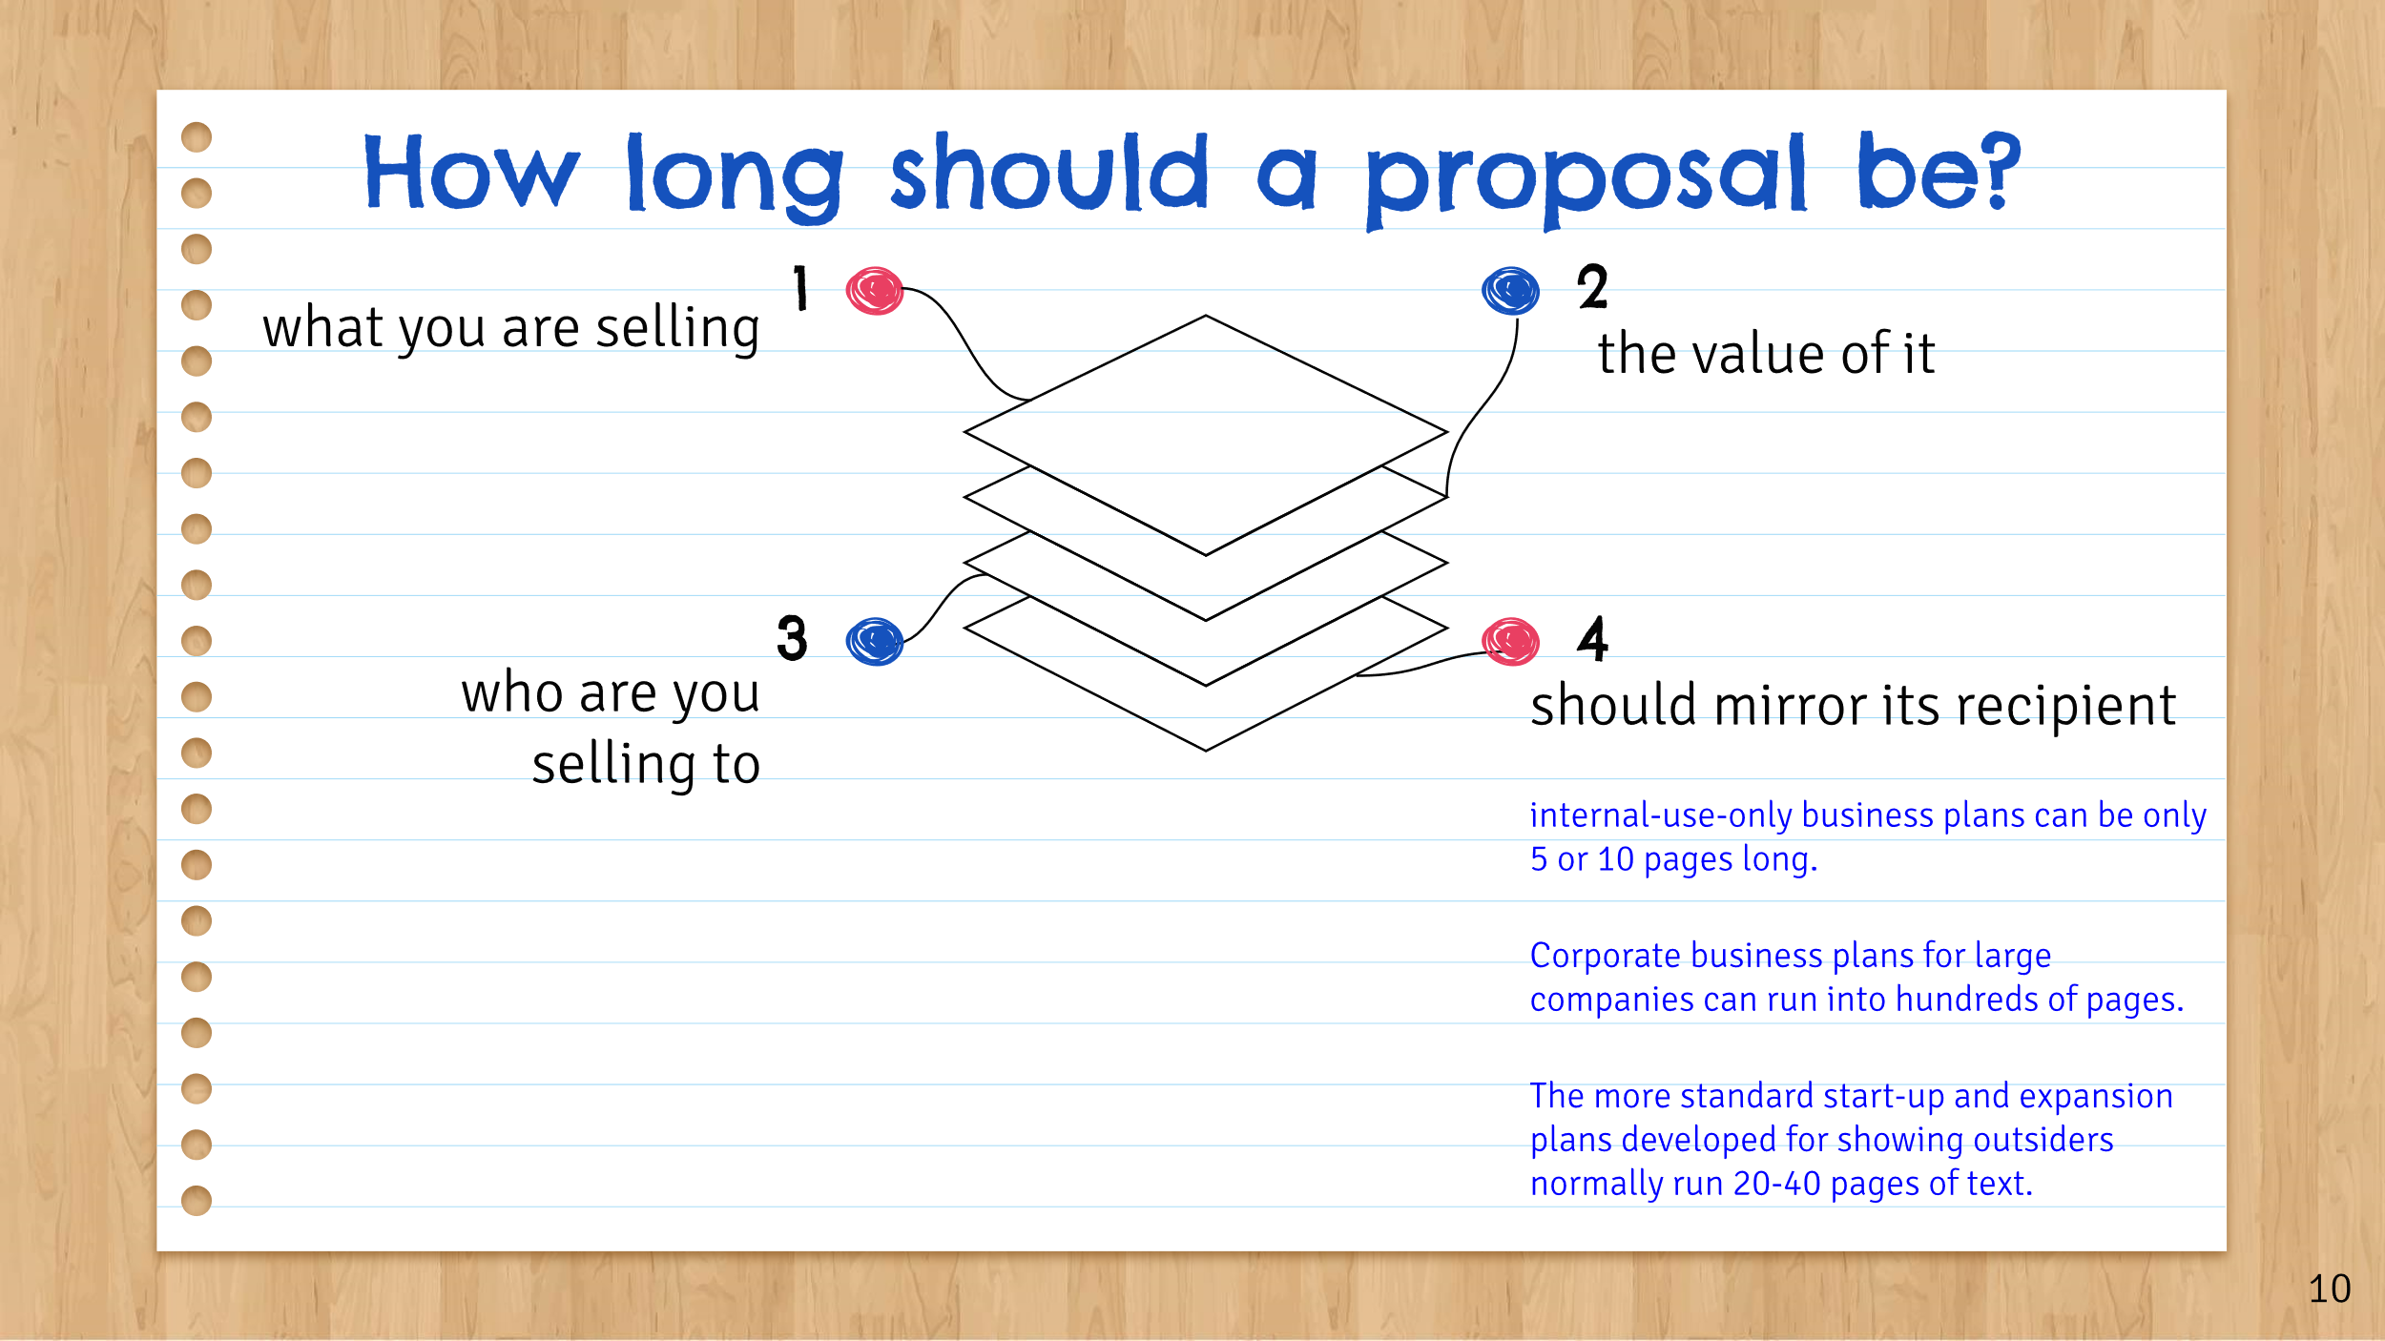



| **Session 3 – TYPES OF A BUSINESS PROPOSAL** |
| --- |











| **Session 4 – REASONS FOR WRITING BUSINESS PROPOSALS** |
| --- |

















| **Session 5 – FORMAT OF A BUSINESS PROPOSAL** |
| --- |

**5A Basic Structure of a Business Proposal**

Regardless of the nature of the business, there are certain elements that are always necessary in writing a proposal.

These elements serve as the fundamental information that the recipient of the proposal will glean from looking at it.

Other business proposal components will be varied based on the type of the business, its size, targeted recipients and many other factors.

The key components essential to just about any business proposal are;

| **Information about** | * Who is the proposer? (designation, qualifications, etc.) * What is his/her business? (credentials and niche of the company, past projects, etc.) | |
| --- | --- | --- |
| * What is the problem faced by the potential client?   **– Problem statement = P1**   * What is the solution to alleviate the problem?   **– Proposed solution = P2**  *OR, if there is no problem identified*  *How will the proposal* ***benefit*** *the client and his/her business?*   * How much is the product / service / project going to cost**?**   **– Pricing = P3**   * What is the proposed product / service / project? * How long will the proposed product / service / project take? | | **Answers to** |
| **Approaches and Methodology** | * What are other resources (i.e., physical resources. Human resources & intellectual resources) required to implement the solution? * How, specifically, is proposer going to solve the problem(s)? | |

**5B Format of a Business Proposal**

Here are **seven (7) general** headings / components of a business proposal;

